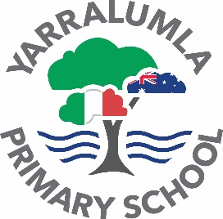
YARRALUMLA PRIMARY SCHOOL
24 Loftus Street, Yarralumla ACT 2600
Phone: 6142 3250
Email: info@yarralumlaps.act.edu.au
Website: www.yarralumlaps.act.edu.au

9 MARCH 2023 NEWSLETTER NO. 3

DATES TO REMEMBER

Friday 10 March | Swimming Carnival Year 2-6  Kindergarten-One Water activities
Monday 13 March | Canberra Day
Tuesday 14 -24 March | NAPLAN Years 3 and 5
Wed 15 -17 March | Year 5/6 Cooba Camp
Monday 20 March | Wombats Preschool Photos
Wednesday 22 March | Whole School Assembly host Year 1 – 2.10pm
Friday 24 March | Bilbies Preschool Photos

Our Vision
Insieme creiamo studenti per tutta la vita - Together we create lifelong learners

Dear Parents and Carers,

P&C – Save the Date – Welcome Community Picnic
Friday 31 March, 5-8pm. Italian Language Day. The P&C are organising a welcome picnic at YPS which will include Italian food vans. Bring your picnic rug and family and join in this wonderful community event.

Reading Information Evening
Our Deputy Principal Lauren hosted a home reading information night for parents on how they could assist their child at home. If you would like further information please contact Lauren or your classroom teachers. A copy of the presentation as well as a volunteers request will be sent home.

NAPLAN
Our year 3 and year 5 students will commence NAPLAN next week. Please let your classroom teacher know if your child has had a change to routine in the lead up to the assessments. If you your child is displaying any level of anxiety around NAPLAN please contact your classroom teacher or Mandy our executive staff member.

104.7 morning show
What a spectacular morning our school community had last week when 104.7 hosted their morning show from the school. A huge thank you to the P&C for organising the treats for sale and cooking the bacon and eggs for community. It was a fantastic to see so many of our parents on school grounds enjoying the morning.

Swimming carnival
Our Years 2-6 swimming carnival will be held at Stromlo pool this Friday. Our rotations and swimming events have been emailed to all parents. A big thank you to the parents that have volunteered their time to help on the day. Our Kindergarten and year 1 students will have a water fun day at school.

Ride to school
Maestra Angela and Elliot led our ride to school on Thursday morning from the Yacht club. It was great to see many of our students participating in this initiative in encouraging more students to ride to school each day and reducing the number of cars around the school.

Assembly
Our year 2 students hosted the assembly this week. Year 2 sharded their recount writing in English and their Italian poems. The students also sang a song in Italian about being at school. Congratulations to all our hard working students who have made growth in their learning for the
Drop off and pick up zone

Keep Smiling,

Rohan Evans | Principal
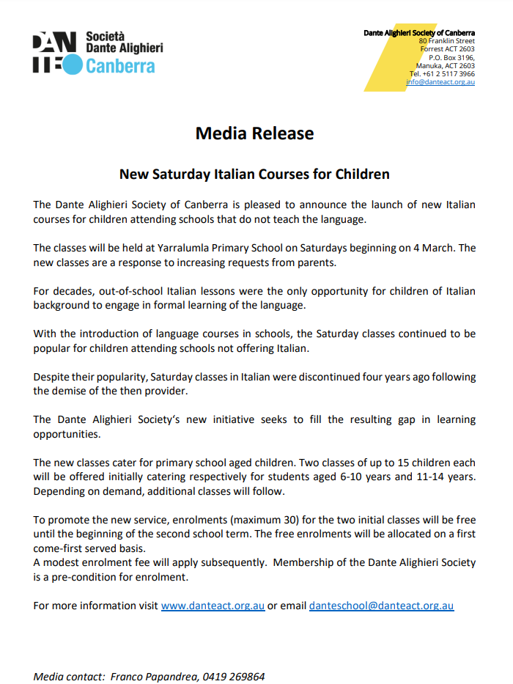

UPDATE – Aeon Academy relocation on 29 March 2023 and thermal upgrades at Yarralumla Primary School.

The Education Directorate is committed to ensuring that all buildings remain safe for the school community and have the infrastructure to support high-quality education.
As you are aware, the Education Directorate will be carrying out targeted thermal upgrades to install double glazed windows within the school. The works will commence 11 April 2023 and will continue for approximately 4 weeks. The replacement windows include the hall, the stage wing and corridor leading to the hall.

The School, the Directorate and the Aeon Academy are working together to ensure there is minimal disruption to the Aeon Academy after-school program.

Updates will be provided fortnightly through the school newsletter until works are complete.

You can learn more about management of hazardous materials in ACT public schools on the Directorate’s website.

If you have any questions or concerns, please contact ACT.Education@act.gov.au


STAR AWARD
Awarded to
March 2023
Safia Nockles

Safia is a responsible and caring student, who demonstrates each of the school STAR values. Her sense of fairness is always evident to fellow students and staff. Safia is eager to learn new concepts and loves to share information about activities she has experienced outside school. Her active participation and consistent effort in all learning areas are highly valued by her teachers. Safia is especially commended for the enthusiasm and motivation she shows in striving to improve her Italian language skills.
Congratulations on this very well-deserved award Safia! Bravissima!

STAR AWARD
Awarded to
March 2023
Maryia Alotaibi

Mariya is a kind and motivated member of our class. She eagerly participates in all aspects of learning. Mariya shares her ideas, asks clarifying questions and takes on challenges to improve her understanding.
She is thoughtful and models each of the school STAR values.
Congratulations on a fantastic start to Year 2. Keep trying your best, Mariya!


Cyber Safety Presentation at Yarralumla Primary
On Monday 27th March at 5:00pm, the school will be hosting a parent-based presentation from ThinkUKnow about cyber safety.
“ThinkUKnow Australia is an evidence-based education program led by the Australian Federal Police (AFP), delivered nationally in partnership with police and industry partners to prevent online child sexual exploitation.
We incorporate up-to-date research, real case studies and examples from reports made to the AFP-led Australian Centre to Counter Child Exploitation.
The program is pro-technology and addresses topics including self-generated child abuse material, online grooming, sexual extortion, and importantly encourages help seeking behaviour.” – ThinkUKnow website, About.
Whilst this is a difficult topic to think about, it is very important to keep ourselves educated, as parents and teachers, about how to handle these topics.
Please note, this session is not suitable for children. It is aimed at adults only, due to the sensitive nature of the content.
Please fill out this google form to indicate your attendance.
https://docs.google.com/forms/d/e/1FAIpQLSdvMtBweemx4KhLOHaV8vAbKpGsFMs9Am8WZPDXlPQP3BIT5A/viewform

For more information and resources please click on the link below.
https://www.thinkuknow.org.au/resources-tab/parents-and-carers
We hope to see you there. Please contact me if you have any questions.
Claire Hansen
Claire.hansen@ed.act.edu.au.
SEESAW AND OTHER DIGITAL APPLICATIONS

Seesaw is a digital portfolio platform that we like to use to communicate with home about student learning. Each class has an account that parents and carers can sign up to so that they can see what is happening in their child’s classroom. Seesaw is student driven; therefore, each child’s portfolio will look different from class to class and year to year. Students are given the opportunity to include items they are proud of, work that shows their achievement of an individual learning goal or a reflection of their learning to make connections. Teachers will also include posts about what the class is currently inquiring into and other parts of school life (e.g., excursions) to keep you connected to what’s happening in the school. As well as a way to help you engage with your child’s learning, Seesaw will be used as one of the main communication tools for announcements and reminders. Teachers will make regular updates in conjunction with the newsletter, emails and hard copy notes. All students will be given a note requesting parent/carer consent for a range of different applications and programs that may be used in the classroom over the course of the year, including Seesaw. Please make sure that you return this note as soon as possible. If you do not wish to use Seesaw, or have difficulty accessing the internet, please speak to your child’s class teacher directly so that a different communication method can be negotiated. We ask that, when you are viewing any items on Seesaw, you do not take screenshots or put any of the material onto other social media platforms to respect the privacy of all parties. We also ask that Seesaw is only used to communicate about learning. It is more appropriate that concerns be raised in person or through email with the class teacher.

School Psychologist Update
Hi! My name is Elisha, and I am a school psychologist based here at Yarralumla Primary School. School psychologists in the ACT support schools and students around inclusive education, and student mental health and wellbeing. I will be sending through occasional articles in your school newsletter which may help you to support your child and their ongoing wellbeing.

Addressing Your Child’s Anxious Avoidance is a 6-week is a group parenting program aimed at helping parents/carers increase their child's ability to cope with anxiety and decrease anxious avoidance. During the program parents/carers will develop a clear plan to address their child's anxious behaviours, recruit and engage supporters, and explore how to communicate without promoting escalation. This program is designed for parents/carers of students in Year 4 to Year 6 who demonstrate anxiety related avoidance that negatively impacts on their life. Please contact Lauren Bruhwiller to discuss if this program is suitable for your family.

If you would like to get in touch with me, to ask questions or require resources to support your child, please contact me through our Deputy Principal, Lauren Bruhwiller on lauren.bruhwiller@ed.act.edu.au

This week’s article aligns with the upcoming E-Safety Talk from Think You Know.

P&C NEWS

Dear parents, carers, students and friends from the YPS community

HIT 104.7 Radio Show live from YPS

What an amazing morning it was when Ned and Josh from HIT 104.7 broadcast from YPS! If you would like to remember the fun we had that morning, download the episode here: https://listnr.com/podcasts/ned-and-josh/radio-show-back-to-school-yps-01-03-23. This episode is a condensed 30 minutes of the mega three hour broadcast. It contains audio of all the games, tests and awards that the wonderful YPS teachers put Ned and Josh through during their great morning at YPS!

A huge thank you for the generosity of the YPS community in supporting the P&C’s catering at the 104.7 broadcast. We had very short notice to bring this together and it was a huge success! We raised a considerable amount of money for the P&C.

Thank you to all the parents (and grandparents!) who baked or bought food for us to sell. Thank you to the poster makers, the epic grocery shoppers and the early morning helpers who arrived in the dark to set up. Thank you to the hot-chocolate-makers and also to the emergency-extra-milk-shoppers (we under-estimated YPS students’ ability to drink hot chocolate!). Thank you to the barbeque team, the bake-sale servers, and the packer-uppers who stayed back after the kids were in class and everyone was gone.

Thank you also to all the parents who stocked their kids’ pockets with gold coins to spend. Our most grateful thanks to the YPS team who worked so hard to prepare for the broadcast before the day. And finally, thank you to all the YPS students who were such amazingly enthusiastic and polite customers and patient queuers throughout the morning.

Notice of P&C Annual General Meeting

The P&C’s AGM will be on Monday 20 March 2023, 6.30pm in the YPS Staff Room and virtually. A virtual attendance link will be sent out closer to the day.

The 2023 Executive Committee of the P&C must be elected at the AGM. The YPS P&C Constitution requires us to have an Executive Committee comprising a President, Vice-President, Secretary, Treasurer and at least two other members (one of whom could be an Assistant Treasurer).

If you are interested in nominating for any of the positions on the P&C, please read about each position here: Roles of the P&C office bearers. If you are considering nominating, please contact the YPS P&C Secretary in advance of the AGM.

All nominees will be asked to complete a Nomination and Declaration Form similar to the one at the link. This is to ensure that the P&C meets its statutory obligations in regard to ensuring candidates are fit to hold office.

Following the AGM we will have a regular P&C meeting with the usual opportunities to raise questions, suggestions or ideas – and hear about YPS.

Future community events

The P&C is planning a program of fun, social and fundraising events for 2023. The next event will be Dantedì. This is an international celebration of the Italian language in late March each year. The P&C is busily organising a twilight community celebration for Dantedì – stand by for more details.

Later in the year, the P&C will be arranging a celebration for International Teachers Day in October where the YPS community can come together to show our great appreciation for our incredible teaching staff.

We will also be having a Grandparents and Grand-friends Day in October. And of course the Annual YPS Disco. Save the date – Friday 24 November 2023. DJ Cliff is booked for another great night. Will it be as good as the 2022 YPS Disco? I’m sure it will be even better!

The P&C Events Sub-Committee will coordinate volunteers progressively through the year. If you have a particular interest in running or contributing to a specific event, or would like to join the sub-committee, please email president@ypspandc.com.

Mother's Day Family Photo Mini Sessions

One of our talented parents, Carly Taylor (www.carlytaylorphotography.com.au) will be holding Mother’s Day Photo Mini Sessions at the school in March.

This will be a fantastic chance to create a beautiful Mother’s Day gift! It is also a fundraiser for the P&C as a percentage of each session fee will be donated to the YPS P&C.

Carly ran a very popular series of mini sessions last year for Christmas family photos. We are excited to be able to offer this opportunity again. This offer is open to anyone so please spread the word to your friends, family and colleagues.

- When: Saturday 18 March, Sunday 19 March, Saturday 25 March and Sunday 26 March 2023

- Where: Yarralumla Primary School Hall, 24 Loftus Street, Yarralumla

- Cost: $160. This includes a 20 minute indoor session and 5 digital images. Additional images will be available for purchase.

- Bookings: https://book.usesession.com/s/jT3KtxiGB

For more information please contact Carly Taylor on 0414 927 156

Mother's Day stall – Friday 12 May

The Annual YPS Mother’s Day stall is a much-loved opportunity for YPS students to purchase gifts for the special woman in their lives.

In order to raise funds, we would be grateful if each family could donate a suitable gift(s) for sale. This could be candles, moisturisers, chocolate, stationery, bracelets – whatever you would like to receive! Gifts will be sold for $5.

There is no need to wrap donations as the gifts need to be able to be seen by students as part of the process of finding the perfect gift. If you do need to wrap a donation, please use clear wrap.

We would be grateful if donations could be brought to school in during Weeks 9 and 10 of Term 1 (from 27 March).

If you have a business that is keen to provide bulk gifts or vouchers please contact us on fundraising@ypspandc.com for an opportunity to promote your business.

And lastly but importantly, the P&C will need some helpers to run the Mother’s Day stall on the Friday morning from 9.00 am to 12pm (or for an hour or two during this period). If you can help, please email us on fundraising@ypspandc.com. It is a lot of fun!

Uniform Shop

The Uniform Shop is open every Friday, 8.30-9.00 am during term time (except Pupil Free Days) for all your preloved and new uniform needs.

Families are also able to order uniforms via Flexischools and have them delivered to the front office for collection.

To enable the Uniform Shop to stay open, we really need more volunteers. If you are able to help regularly or even a one-off please email uniform@ypspandc.com

That’s it from the P&C. We hope to see many of you at the P&C AGM!

Patience Neal
P&C President
president@ypspandc.com



Become an ACT public school Homestay host
The ACT Education Directorate is seeking Homestay hosts for international students planning to study at an ACT public high school or college. International students participating in the Homestay program are aged 16 years or above.

Homestay is more than providing a room and meals. You’ll welcome a young person into your family and support their growth as they gain new perspectives, confidence, English fluency and academic and essential life skills.

If you can offer a place in your home, have the time to support a student’s social wellbeing and academic endeavours and have an interest in other cultures, we would love to hear from you.

A weekly payment is provided to help cover the costs of living expenses.

Please contact the International Education team via email at: ieu@act.gov.au or by phone on (02) 6205 9194. To find out more visit Homestay.

Soccer
The Croatia Football Club is currently looking for some more children under the age of 12 years to join the clubs under 12s soccer team.

Training is held on the sports ground at YPS on Monday and Wednesday evenings from 5 30pm.

The club would love to hear from anyone who is interested in joining many fellow students from YPS.

If so please feel free to contact the club directly via the email address listed below

info.canberracroatiafc@gmail.com


Year 2: Smeraldo - Giada

Skip Counting Challenge
Last week we used our skip counting skills to try and find out how many wheels there would be on a certain number of ACT buses.
Depending on their length, buses in Canberra can have either 4 or 6 wheels. Therefore, we practised counting by fours and sixes.
We made pictorial representations of groups of 4 and 6 wheels to help us skip count, considering more than 10 buses.
Next time you see a bus depot or a few buses in line, try using skip counting to find out how many wheels there are all together.

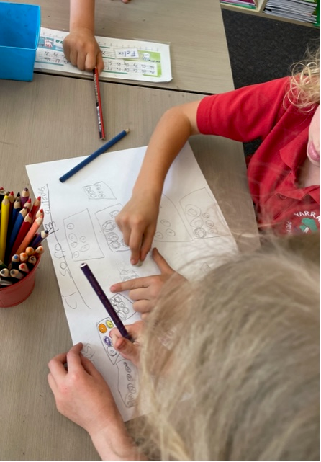
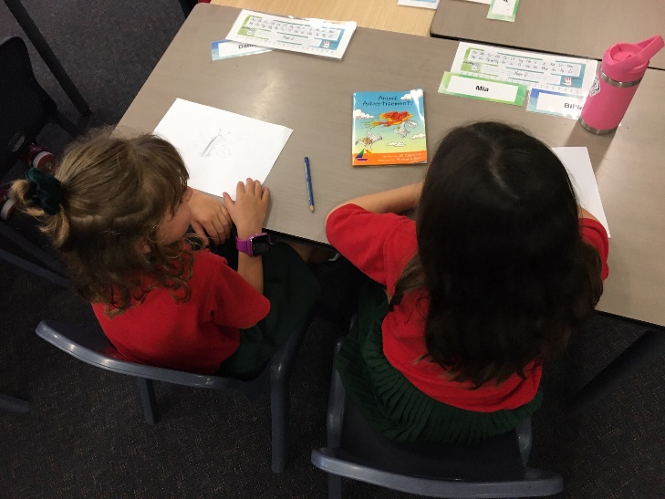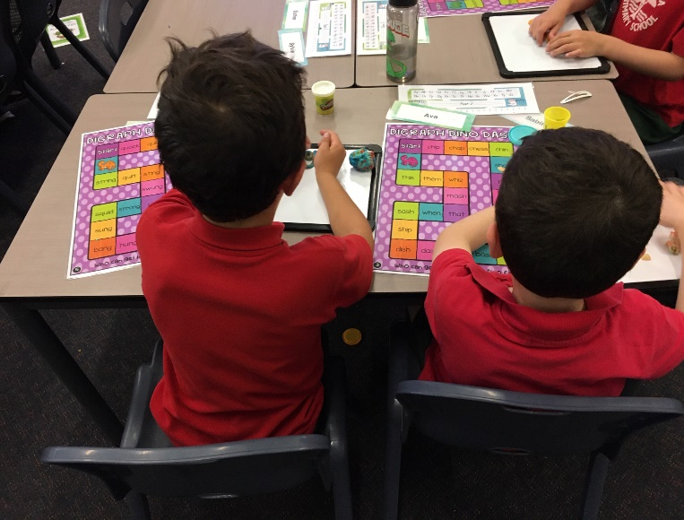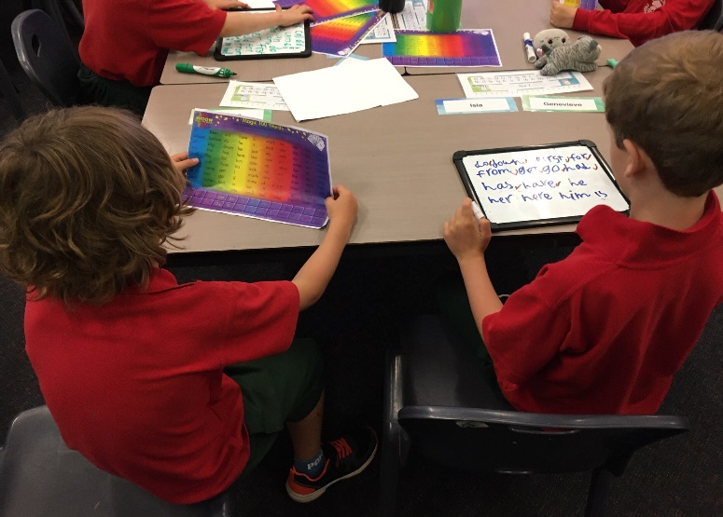
Reading Groups
Since week 4 we have established rotational Reading Groups in the English classroom.
Students have had the opportunity to participate in a variety of activities which foster group reading, learning sounds, how to rhyme, spelling and comprehension.

Yarralumla has two student teachers from the University of Bergamo arriving in April 2023 and a third student arriving in June 2023.
We are seeking families to host them during their internship!

Dear Parents and Carers

Again this year, we are very fortunate to be hosting three student teachers from the University of Bergamo! Last year Yarralumla Primary School hosted three student teachers from the University. When these students returned to the University they were asked to speak to their cohorts and detail their experiences at Yarralumla Primary School. They were so enthusiastic that we had six students asking to complete one of their teacher internships with us in 2023. However, the University of Bergamo only authorised three scholarships.

Hosting student teachers at Yarralumla is an enriching and exciting experience for the visiting student teachers, Yarralumla teachers, and of course, our students and their families! They bring to our school energy, vitality, new ideas, create resources for the Italian program and share their Italian pedagogy.
I am writing this notice to call for expressions of interest from our school families interested in hosting one of these three student teachers. If you are in a position to accommodate a student with their own bedroom and ensuite, live close to school so the student teachers can walk to school, or if not, are in a position to drop them off and pick them up each day from school, we are very interested in hearing from you.
Our first two student teachers, Valentina Magenga and Sara Fustella, arrive in Canberra on 20 April 2023 at 22:00. Valentina leaves Canberra on 27 June 2023 and Sara leaves Canberra on 10 June 2023. Our third student teacher, Alessia Tallarini, arrives in Canberra on 15 June 2023 at 20:00 and departs on 4 September 2023.

The student teachers will be at Yarralumla Primary School for approximately ten weeks. All three student teachers will send brief biographies of who they are and an accompanying photo. These will be sent to the host families. The host family will be able to contact the students before they leave Italy and that way get to know they a little before they arrive.

If you are interested in hosting one of these young teachers and would like more information regarding this opportunity please contact me via email at: Lynden.Lawton@ed.act.edu.au

I look forward to hearing from you!
Maestra Lynden

