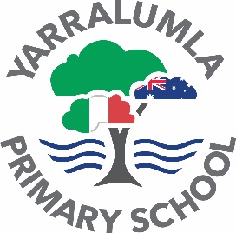

YARRALUMLA PRIMARY SCHOOL

24 Loftus Street, Yarralumla ACT 2600

Phone: 6142 3250

Email: [info@yarralumlaps.act.edu.au](mailto:info@yarralumlaps.act.edu.au)

Website: [www.yarralumlaps.act.edu.au](http://www.yarralumlaps.act.edu.au/)



31 June 2022 NEWSLETTER NO. 10

***DATES TO REMEMBER***

|  |  |
| --- | --- |
| Friday 1 July | PJ Day whole school |
| Friday 1 July | Last Day of Term 2 |
| Monday 18 July | First Day of Term 3 |
| Monday 1 August | Year 5/6 Excursion to Birrigai |
| Monday 8 August | Athletics Carnival |
| Wednesday 24 August | Book Week Performance |

Our Vision

Insieme creiamo studenti per tutta la vita  -  Together we create lifelong learners

**School Reports / Parent Teacher Interviews**

Our semester one reports will be sent home to families this Friday via email.  If you do not receive a copy of your child’s report please contact the front office.  Our semester 1 reports are slightly different this semester with only one general written comment.  Parent teacher interviews are available in weeks 9 and 10 in the classrooms.  Please use the online booking form to request an interview if you have any questions about your child’s academic or social/emotional progress.  The online booking system will close this weekend.  If you miss out on using this system please contact your child’s teacher/s directly to request an interview.

**Supporting students at home**

The school has purchased a number of online resources to support students at home with their learning.  Our students in K-2 have the use of Reading Eggs to support their literacy learning.  Our students in K-6 have the use of Matific to support their learning in Mathematics.  For our students in Years 3-6 Education Perfect is used to support and reinforce students learning in Italian.  Please contact your child’s teacher if they do not have a copy of their log in or password to any of the programmes.  Please ensure your child is bringing home books from the school library each week and our students in K-2 are regularly changing their home readers.  We have a number of wonderful Italian picture and chapter books for students to borrow from the library.

**Enrolments**

Enrolments for Preschool, Montessori 3 year old program and K-6 are currently open.  We have a number of spaces still available in our programmes for 2023.  If you are aware of any families that would love to join our bilingual school to attend one of the unique programs please encourage them to complete an online enrolment form.  Opportunities for school tours are available with the Principal.

**Assembly**

This week our Year 1 students did a wonderful job of hosting the whole school assembly.  They presented work to the school in both English and Italian including an Italian song. Congratulations to all our award recipients.

**Athletics Carnival**

We have booked our athletics carnival for Monday 8 August at the Woden athletics track.  We will be supported by students from St Edmunds College on the day to assist in running all of the events.

**Board and P&C meeting**

Our School Board and P&C will meet on Monday 20 June, with the P&C meeting on Wednesday 29 June in the library at 5pm.  The P&C will be conducting their AGM if you wish to volunteer for one of the positions for the remainder of the year. It is a great way to contribute to the school community.

**Teaching Changes**

Letters have been sent home to our students in Year 3/4 and Year 1 as maestro Stefano has taken leave for weeks 8 to 10 this term and maestra Federica for Term 3.  We look forward to the safe return of our two Italian teachers who will be spending much needed time with family overseas.  The school has organised relief teachers to cover these two classes and maintain the students learning in Italian.

Keep Smiling,

**Rohan Evans | Principal**

Week 10 events:

**PJ day**

**Disco** for 3-6 during lunch

**Disco** for K-2 during recess

**Gold coin donation** to be collected in the morning (all money raised to go towards the year 6 gift to the school)

 **STAR AWARD**

Awarded to

***Aarna J***

***June 2022***

Aarna is an extremely motivated and conscientious member of our class. She eagerly participates in all aspects of learning - always striving to improve and do her absolute best. Aarna is inclusive, thoughtful and demonstrates great responsibility as an ICT Leader. Each day she models each of the STAR values which are valued at Yarralumla. Congratulations on your achievements and for being an exceptional role model, Aarna!

 **STAR AWARD**

Awarded to

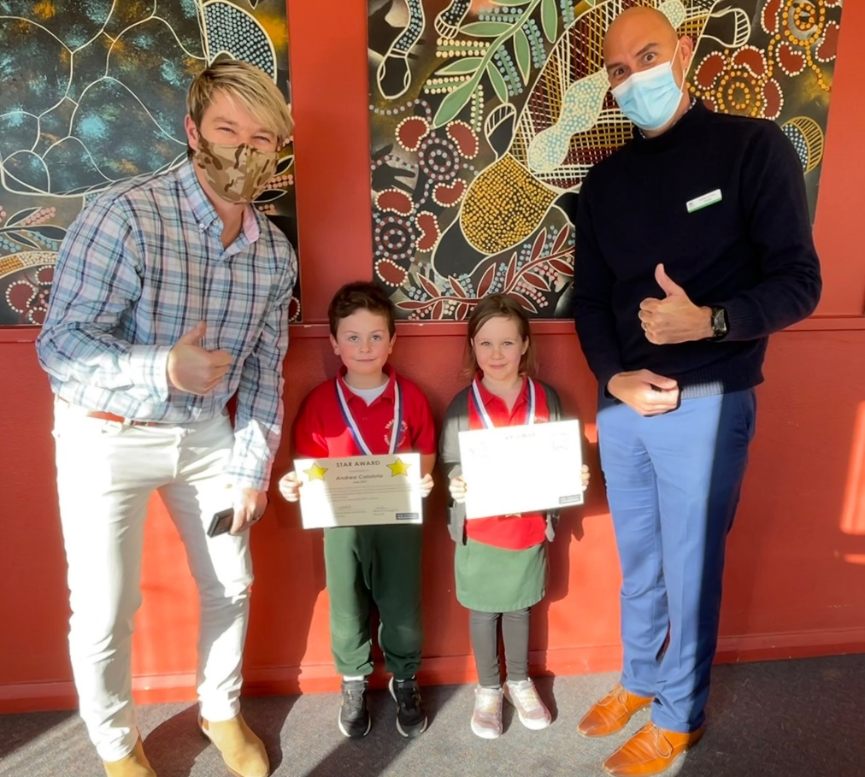

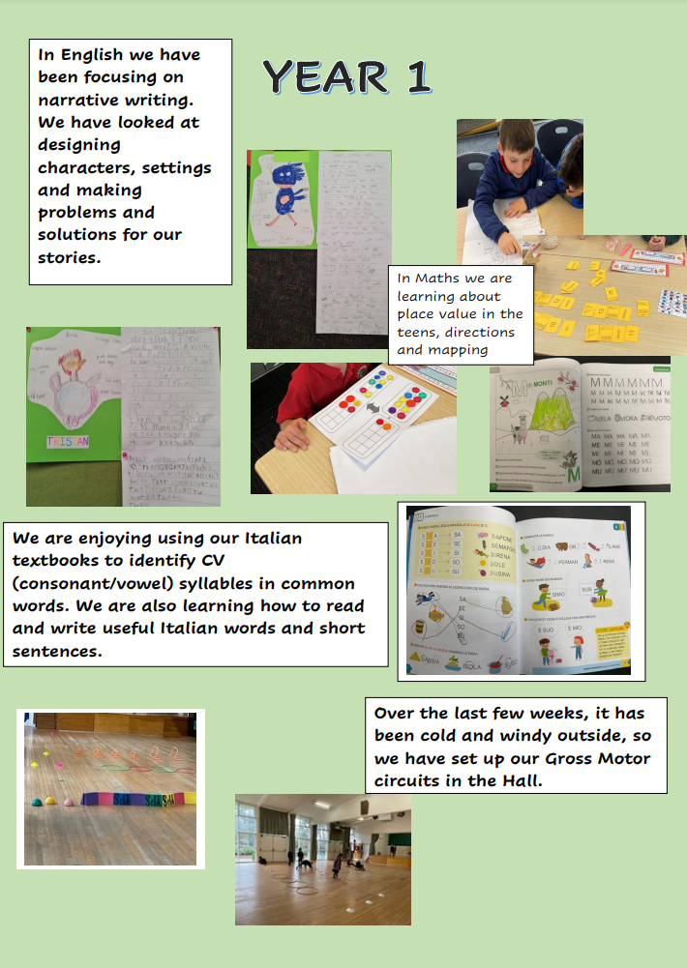

**PBL (Positive Behaviour for Learning)**

**Online safety**

As part of being safe at school, we work with students to ensure they are safe online.

It’s important for students to know who to speak to if something makes them feel

uncomfortable online. I have started talking with our senior students this week about how they can keep themselves safe. This discussion will continue next week and up until the holidays. Some of the things we have discussed are:

*When you are feeling upset with something you have seen online, it can be hard to figure*

*out who to speak to. It’s important to find a someone who will listen to how you feel.*

*You might feel comfortable sharing how you feel with:*

*• a family member, like a parent, an aunty or uncle, or an older brother or sister*

*• a sports coach or music teacher*

*• a friend’s mum*

*• a favourite teacher at school*

*• a neighbour.*

*Talk to your support person regularly about what happens online. This can make it*

*easier to go to them about something serious.*

**Discussion question for you to ask your child at home**: Who would you talk to if someone made you feel unsafe online?

**Our awards**

So far this term we have had 5 people reach the 50 eSTAR level; and 4 people reach the milestone of 100 eSTARs. I am working with our PBL team in the Directorate to see if we can ensure that eSTARS roll over from one year to the next. Students are doing so well in our Junior years that we will need to increase our levels to platinum and diamond before too long 😊

SAFE = 100, TEAM PLAYER = 162, ACTIVE LEARNER = 295, RESPECTFUL = 230

Minor Negative incidents = 14 Physical contact being most prevalent following by inappropriate language.

Major Negative = 2 Both involving physical aggression out on the playground. Both incidents were dealt with immediately by the teacher on duty and referrals made to exec for parent communication.

As always, I am happy to discuss PBL with anyone who is interested in joining our team

[debra.sayers@ed.act.edu.au](mailto:debra.sayers@ed.act.edu.au)

Keep being STARs

Deb

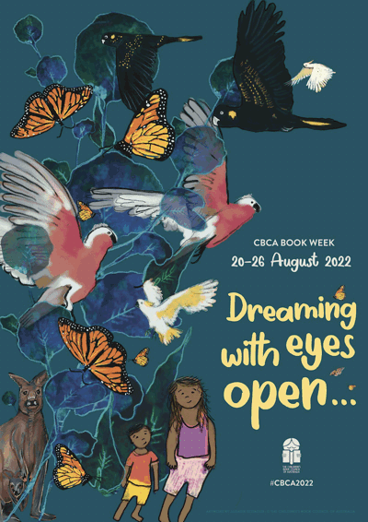**BOOK WEEK 2022 is coming up!**

On WEDNESDAY of WEEK 6 in TERM 3, we will be celebrating book week. This year’s theme is “Dreaming with eyes open”. Okay so it’s not *right* on our doorstep, but if you’re anything like me, it will sneak up on you anyway.

Book week is an amazing opportunity to develop the joy of reading, as well as the higher order thinking skills of analysing, evaluating, and creating. It is also a great way to support independence and responsibility with careful guidance and support.

We will be recognising students whose costumes:

* Are chosen and created by their own minds and hands
* Are composed mainly of recycled or renewable materials
* Represent a character in a creative way

|  |  |
| --- | --- |
| Rest of Term 2, holidays | Every time you read a book together, talk about what makes the characters special. Look at the pictures and talk about what they are wearing, how they might walk or what they might sound like. |
| Talk to your child about the books they are reading independently, who would be an interesting character to see in real life? How could we dress up as them? |
| Remind your child that any reader can identify with any character. We don’t have to share the same gender, skin colour, body type, age, height, facial features, hair colour, or any other physical feature. Anyone can dress up as anyone, we just need to represent them in our own way. For example, wear a skirt instead of shorts, or a scarf instead of a beard. If your character has a different skin colour, wear yours. |
| term 3, Weeks 1-2 | Help your child choose their character and assist them in making a list of all the items they need. |
| Weeks 3-4 | Look and ask around for costume items  Assist your child to make some items |
| Week 5 | Make or buy whatever is left  Print a copy of the book cover and/or a picture of the character, or write it on a card to pin to your child. |
| Week 6 | Wednesday morning- Your child wears their costume to school and has a great day talking about all the books they’re going to read next! |

ENROLMENTS 2023

**It’s not too late to enrol for 2023**

If you forgot to enrol your child or young person in an ACT public school for next year, don’t panic. Enrolments remain open throughout the year. You can find out more information and [apply online](https://www.education.act.gov.au/public-school-life/enrolling-in-a-public-school). Support is also available from this school or by calling the Enrolments Telephone Service weekdays on 6205 5429.

Attachments:

* [Enrolments 2023 still open_Facebook (251 kb JPG)](https://actedu.sharepoint.com/:i:/r/sites/Intranet-Education/Shared%20Documents/20220614%20-%20SB%20-%20W8A6%20-%20Enrolments%202023%20still%20open_Facebook.jpg?csf=1&web=1&e=ilfu3X)
* [Enrolments 2023 still open_Insta (323 kb JPG)](https://actedu.sharepoint.com/:i:/r/sites/Intranet-Education/Shared%20Documents/20220614%20-%20SB%20-%20W8A6%20-%20Enrolments%202023%20still%20open_Instagram.jpg?csf=1&web=1&e=u0S2K4)

Contact Glen Howard on 02 620 55485 or [Glen.Howard@act.gov.au](mailto:Glen.Howard@act.gov.au).

**LOST PROPERTY IS OVERFLOWING**

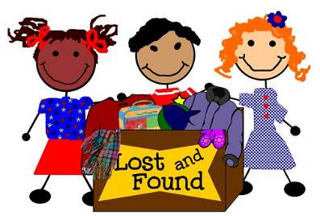Are you missing uniform items, hats, lunch boxes etc.? As the end of term approaches we again will be looking at disposing of lost property which is not labelled. Uniform items will be given to the uniform shop and non-uniform items will be given to charity. Please check, or get your children to check, the lost property area for anything that may be yours.

PENCIL**Lost Property Items include**

* Track pants
* School jumpers
* School jackets
* School hats
* T-shirts
* Skirts
* A variety of plastic containers
* Drink bottles
* Parkas and Jackets

**Please ensure your child’s name on their clothing etc. and regularly check lost property for their belongings.**

he ACT Education

Directorate will also not be providing A-E grades in line with other states and

Leaving Yarralumla?

We are currently organising classes for 2023 and require families to indicate if they will not be continuing at Yarralumla School. A response is **not** required if your child is currently in Year 6 and will be going to High School in 2022.

**Leaving Yarralumla Primary School P-Yr 5 only:**

If your child/ren (not Year 6) **will NOT be returning to Yarralumla School in 2023** could you please complete the form below and return it to the Front Office ASAP.

Child’s Name:_________________________________ Class:______________

Child’s Name:_________________________________ Class:______________

Child’s Name:_________________________________ Class:______________

The child/ren will be attending:

 another Government school in the ACT   a Non-Government school in the ACT

  an Interstate school   an Overseas school

**Community News**

**New ACT Health flu vaccination factsheets in 7 languages**

ACT Health has translated information about flu vaccinations into seven languages: Arabic, Dinka, Filipino, Hindi, Simplified Chinese, Spanish and Vietnamese.

Please consider sharing these [flu vaccination factsheets](https://health.act.gov.au/services-and-programs/immunisation/influenza-flu/resources) with your school community.

**2022 NDIS Expo – Thursday 4 August 2022 from 5 – 7pm**

NDIS (National Disability Insurance Scheme) Expo is at The Woden School on Thursday 4 August from 5:00 pm to 7:00 pm. The Woden School, together with Black Mountain School, invite you to attend an evening with NDIS providers and organisations to showcase after school care, support workers, holiday programs and post school options for students.

The event will be a fantastic opportunity for parents and carers to meet with a range of NDIS providers and find out what they have to offer. For more information, contact The Woden School on 6142 0200 or email Tina Wilson at [tina.wilson@ed.act.edu.au](mailto:tina.wilson@ed.act.edu.au).

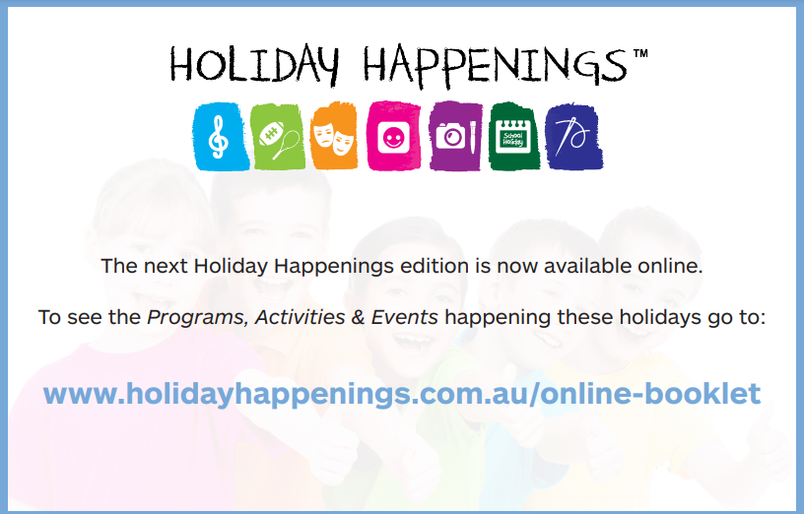

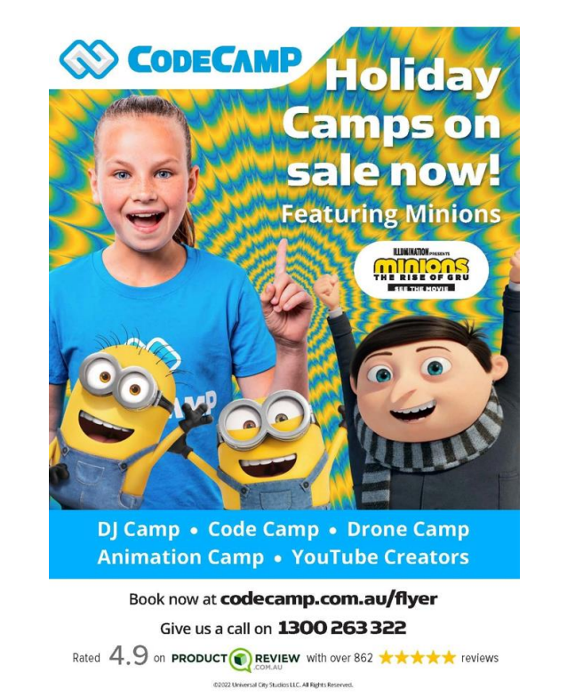

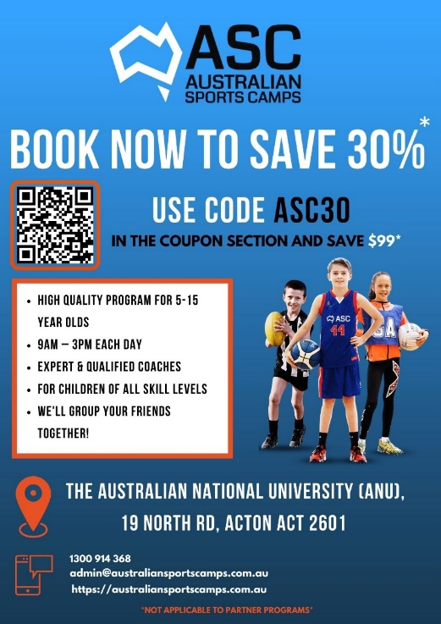**Australian Sports Camps**

Australian Sports Camps runs 3-day sports camps for primary aged children in the school holidays. The camps welcome children aged 5 to 15 of all skill levels to join them for fun, skill-building sports programs over the holidays. Find more information on their website at https://australiansportscamps.com

